**Graphing**

Equation 11: 

Where $\frac{dE}{dd}=Emax*(1-\frac{E}{Emax})(1+\frac{aE}{Emax})(1+\frac{bE}{Emax})$ where a doesn’t equal b > 0.

Using the code from R script and the package dEsolve. Here are the following graphs. These graphs represent the solution to the differential equations assuming initial value d = 0 and E = 0. And r1=r2=0.5

*Figure 1: Orange Curve = IDER, Red Curve = dE2 (Emax = 20), Green Curve = dE1 (Emax = 10)*

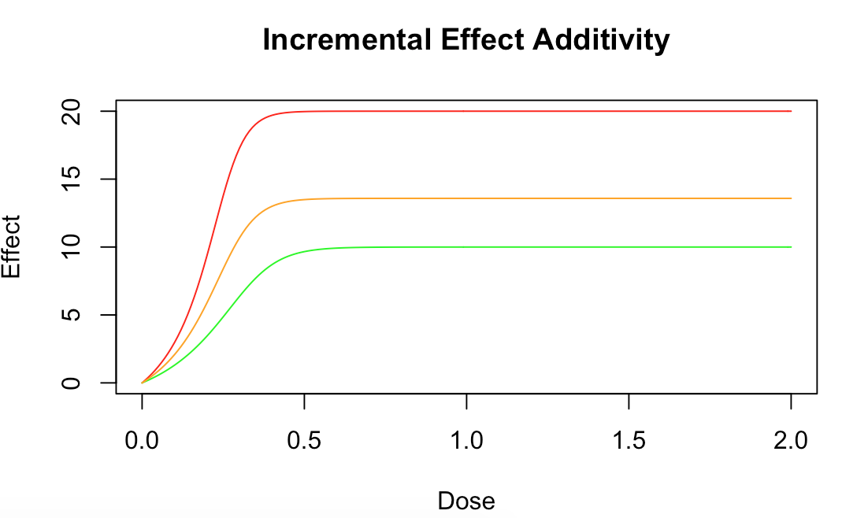

For the following simulation we have assumed 2 dE/dd curves with a = 2 b = 4 for the first one and a = 3 b = 5 for the second one. The Emax’s used is 20 for the first one and 10 for the second one. Hence figure 1 shows the red curve with Emax = 20 and the green curve with Emax = 10 and the orange curve in between showing the incremental effect additivity curve. Note that the maximum of the orange curve it not exactly 15 but around 14 and showing that these two individual curves are fighting each other. We will also prove this later on mathematically.

**Verifying analytically the code works**

Figure 2

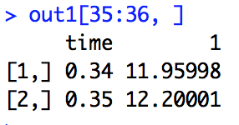

Figure two shows effect at dosage 0.34 and 0.35 of the orange curve in figure one or the solution to the dI equation. To verify that this is code is working analytically we have taken a small interval of dosage at around E = 12 and will approximate the slope of it and see if it reflects the dI/dd value at the certain effect.

Slope using R:

Choose two points: (0.38, 0.2677469) and (0.39, 0.3629748)

Slope: $\frac{0.03629748-0.2677469}{0.020-0.015}=\frac{0.0952279}{0.005}=24.003$ Approximately.

*\* Note this won’t be exactly correct at E = 12 because I have not calculated the derivative of this function at a point using proper differentiation but rather used approximation at two points extremely close to E = 12.*

Slope using analytically equation:

Note from above: Emax1 = 10, Emax = 20, a1 = 2, a2 =4, a3 = 3, a4 = 5, r1=r2=0.5



. $\frac{dI}{dd}=0.5*10*\left(1-\frac{E}{10}\right)\left(1+\frac{2E}{10}\right)\left(1+\frac{4E}{10}\right)+ 0.5*20*(1-\frac{E}{20})(1+\frac{3E}{20})(1+\frac{5E}{20})$

@ E approx. 0.32 .

$\frac{dI}{dd}=0.5*10*\left(1-\frac{12}{10}\right)\left(1+\frac{2*12}{10}\right)\left(1+\frac{4*12}{10}\right)+ 0.5*20*(1-\frac{12}{20})(1+\frac{3* 12}{20})(1+\frac{5*12}{20})$

. $\frac{dI}{dd}=-19.72+44.8=25.08$

Error %:

. $\frac{Exact-Approx}{Approx}=\frac{25.08-24.003}{24.003}=4\%$

A 4% error from the approximation is close enough to substantiate the code written to show analytically that it is working properly and that the modeled graph in figure 1 is proven to be correct solution to the ordinary differential equations.

What was also noteworthy to prove figure 1 analytically is that

$$\frac{dI}{dd}=0.5*10*\left(1-\frac{12}{10}\right)\left(1+\frac{2*12}{10}\right)\left(1+\frac{4*12}{10}\right)+ 0.5*20*(1-\frac{12}{20})(1+\frac{3* 12}{20})(1+\frac{5*12}{20})$$

Actually proved that these two parts will fight each other when exceeding the maximum. As we can tell E = 12 > 10 > Emax1. Therefore the first part of the equation is actually negative as the first part of the equation becomes $\frac{dI}{dd}=5*\left(-0.2\right)\left(1.24\right)\left(5.48\right)+ 0.5*20*(1-\frac{12}{20})(1+\frac{3* 12}{20})(1+\frac{5*12}{20})$. This shows that the left hand side becomes negative proving that these two will fight each other producing that middle orange curve in figure 1.

**Testing out different combinations**

Two cases to test out

1. Testing out different r1 and r2 values to see how that will affect the dosage required to reach the maximum effect for the IDER curve
2. Testing out different values of the shape parameters (a and b) to see how it’ll affect the curve

Testing different r1 and r2 values

To test different r1 and r2 values we will keep all the other values constant when showing these multiple graphs.

Emax1 = 10, Emax2 = 20, a1 = 2, b1 = 4, a2 = 3, b2 = 5.

*Note: red curve = Emax2 of 20, green curve = Emax1 of 10, orange curve = IDER curve.*

Figure 3 (repeat of figure 1): r1 = r2 = 0.5



Figure 4: r1 = 0.3, r2 = 0.7

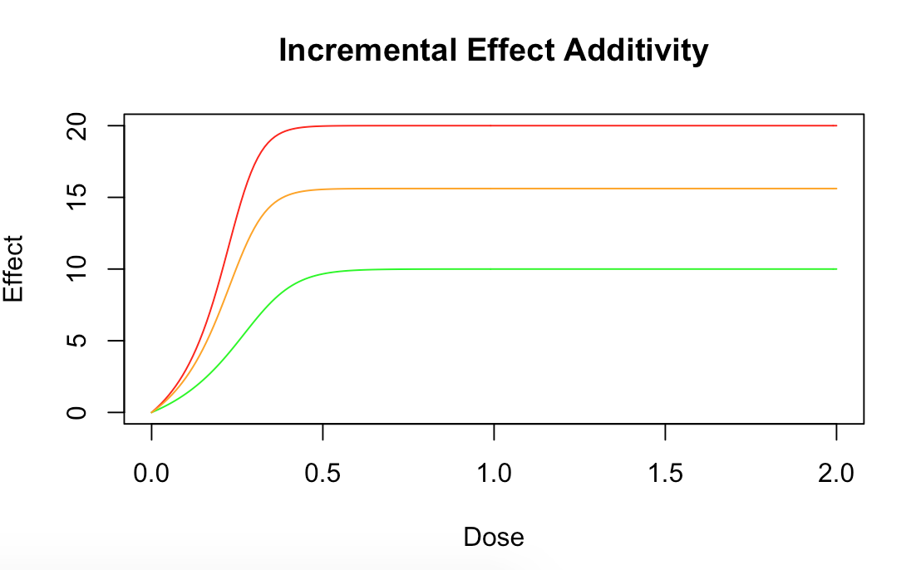

Figure 5: r1 = 0.7, r2 = 0.3

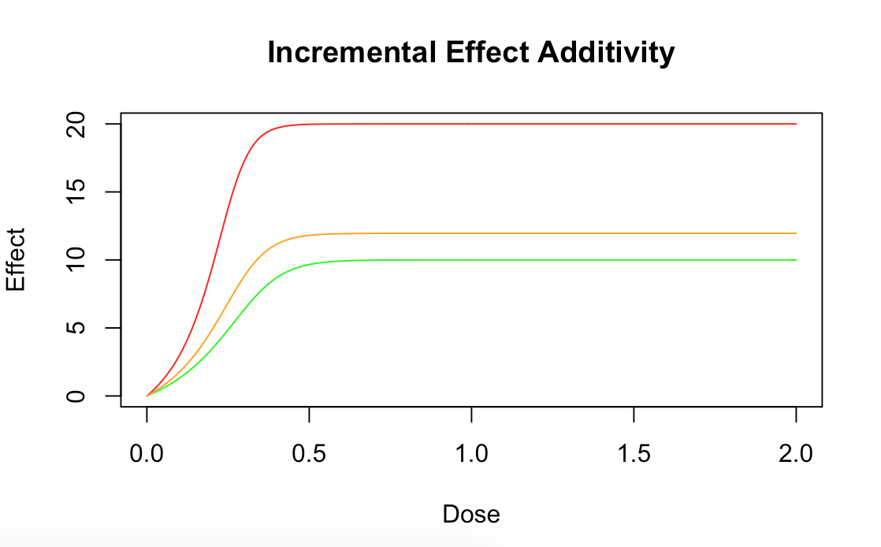

Figure 6: r1 = 0.1, r2 = 0.9

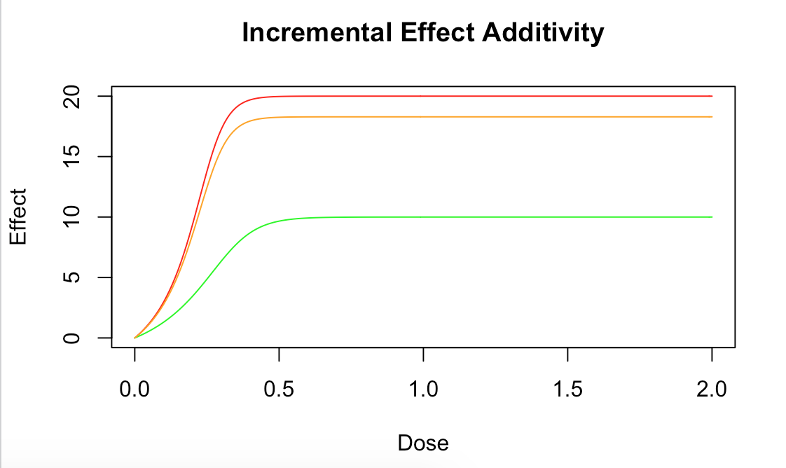

Figure 7: r1 = 0.9, r2 = 0.1 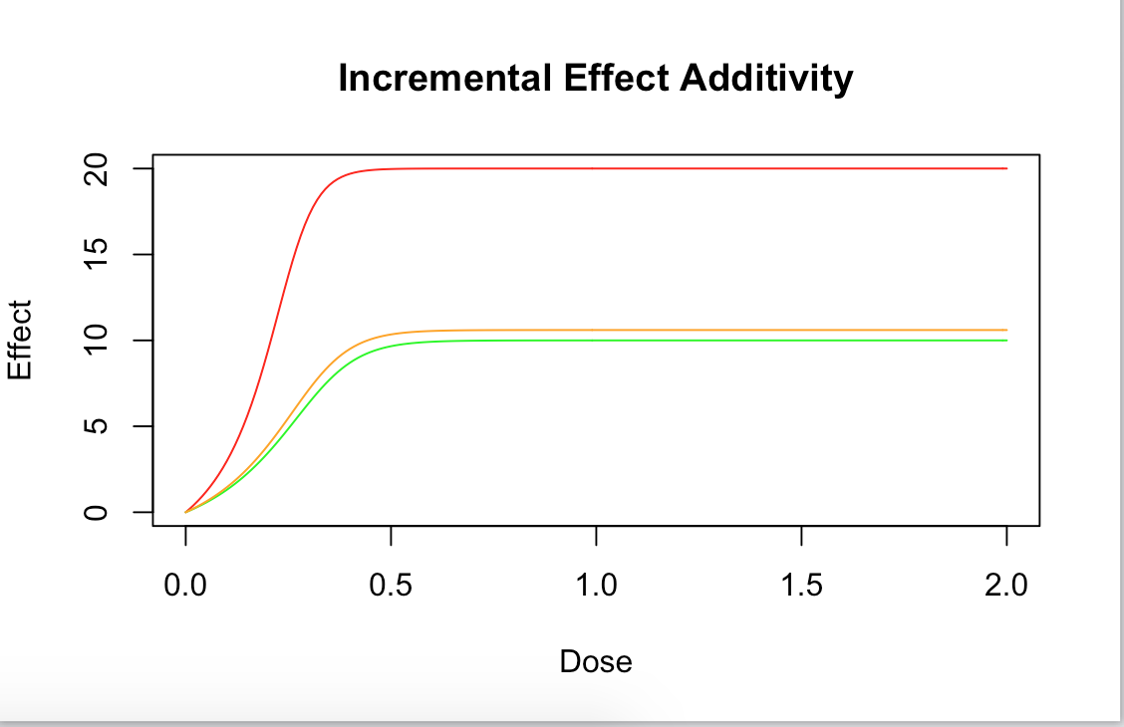

Conclusion:

Just as expected changing the values of the r1 and r2 made the IDER curve echo more of dE1 or dE2. For example, in in the extreme cases of figure 6 and figure 7 when r2 = 0.9 or r1 = 0.9 the IDER curve almost imitated just the behavior of the respective dE2 or dE1. This makes sense because the variable “r” represents the proportion the individual dE’s are affecting the IDER. If r1 was for example actually 0 we would see the orange curve imitate exactly the red curve and the green curve would have no impact at all.

Testing Case 2: Different values of shape parameters

To test different values of shape parameters I will be changing each shape parameter in an isolated case and see how that changes the curve with respect to figure 1.

*Note: r1=r2=0.5 will stay the same. So as Emax1 = 10 and Emax2 = 20.*

Figure 8 (same as figure 1): a1 = 2, b1 = 4, a2 = 3, b2 = 5



Figure 9: a1 = 10, b1 = 4, a2 = 3, b2 = 5

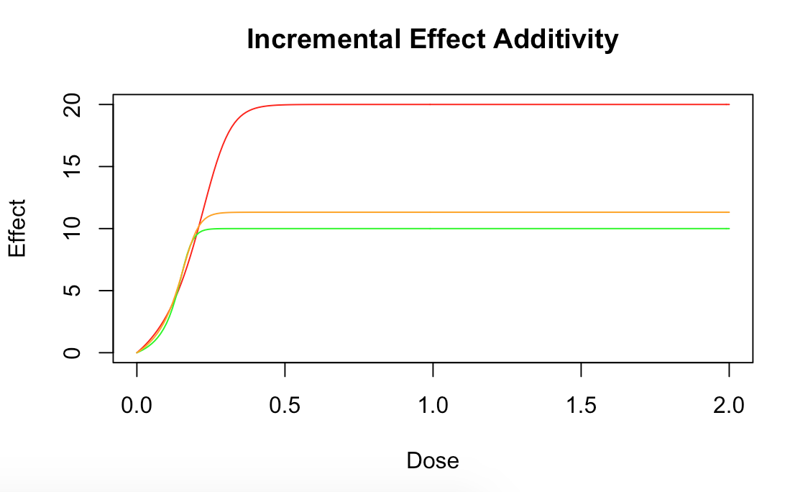

Figure 10: a1 = 2, b1 = 10, a2 = 3, b2 = 5

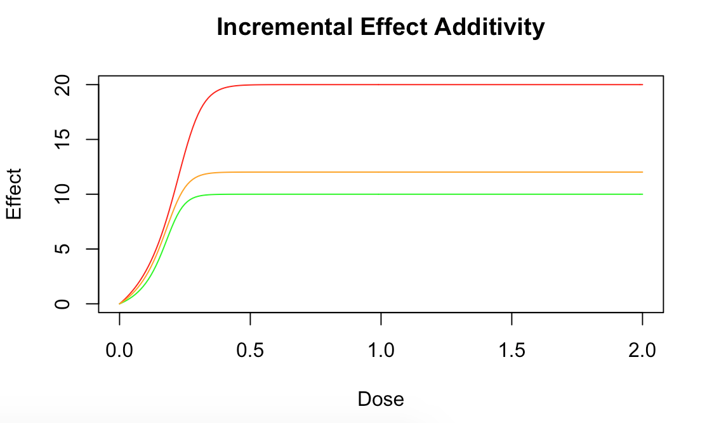

Figure 11: a1 = 2, b1 = 4, a2 = 10, b2 = 5

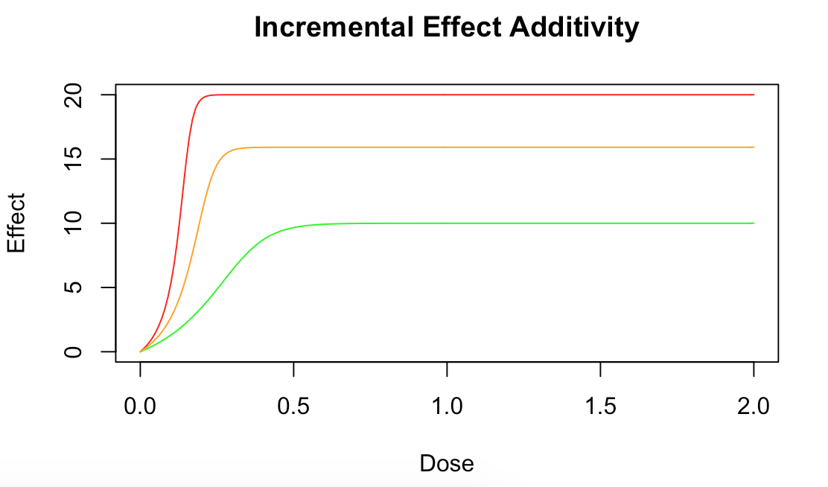

Figure 12: a1 = 2, b1 = 4, a2 = 3, b2 = 10

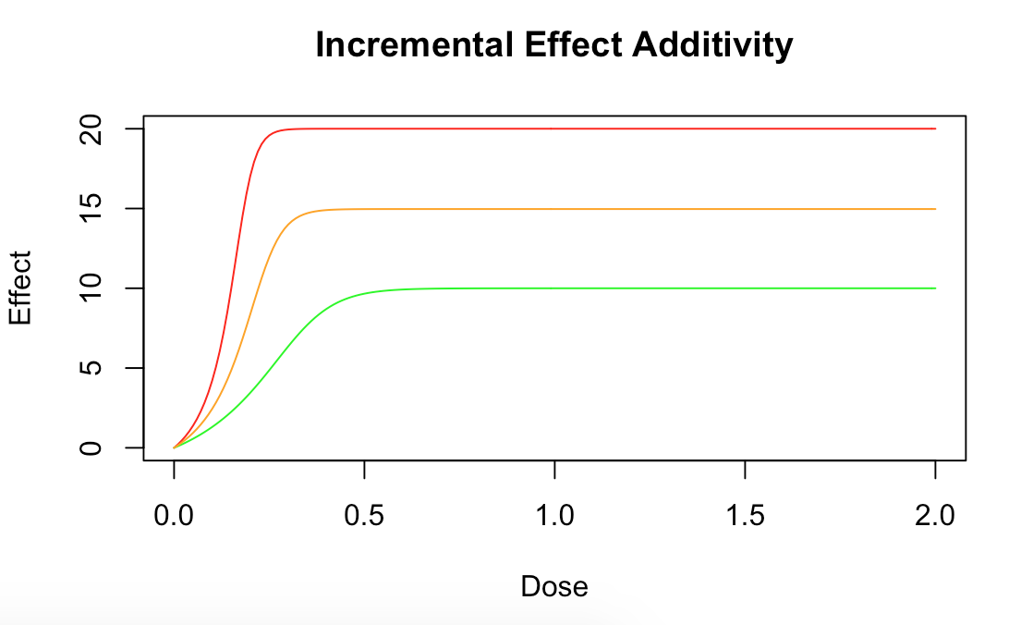

Conclusion:

The Emax for this IDER curve of figure 9 and 10 decreased compared to figure 8 because the changes made to the shape parameters only applied to a1 and b1, which were the shape paramters for dE1 with the lower Emax = 10. It was observed that when changing a1 to 10, the IDER curve reached the maximum effect faster than when changing b1 to 10. However, the maximum value for figure 9 and figure 10 are different. Although changing a1 to 10 does make the IDER curve reach the maximum effect faster the maximum value is actually less than that figure 10 where b1 was 10 as opposed to a1 being 10. However, what’s most important is what a1 + b1 is. When a1 + b1 is relatively large the Emax of the IDER curve will be relatively small or closer to the respective dE curve but will take a larger dosage to reach that Emax than when a1 + b1 is small. This fact is reflected in the last two figures as well. The last two figure shows the Emax are increased compared to figure 8 because this time the changes of a2 and b2 reflects the changes made to the bigger Emax which is Emax2 = 20. The same conclusion is true for this case where a2 + b2 being greater shows a greater Emax for the IDER curve but a larger dosage needed to reach this higher Emax.